
AniMeals on Wheels

In partnership with the
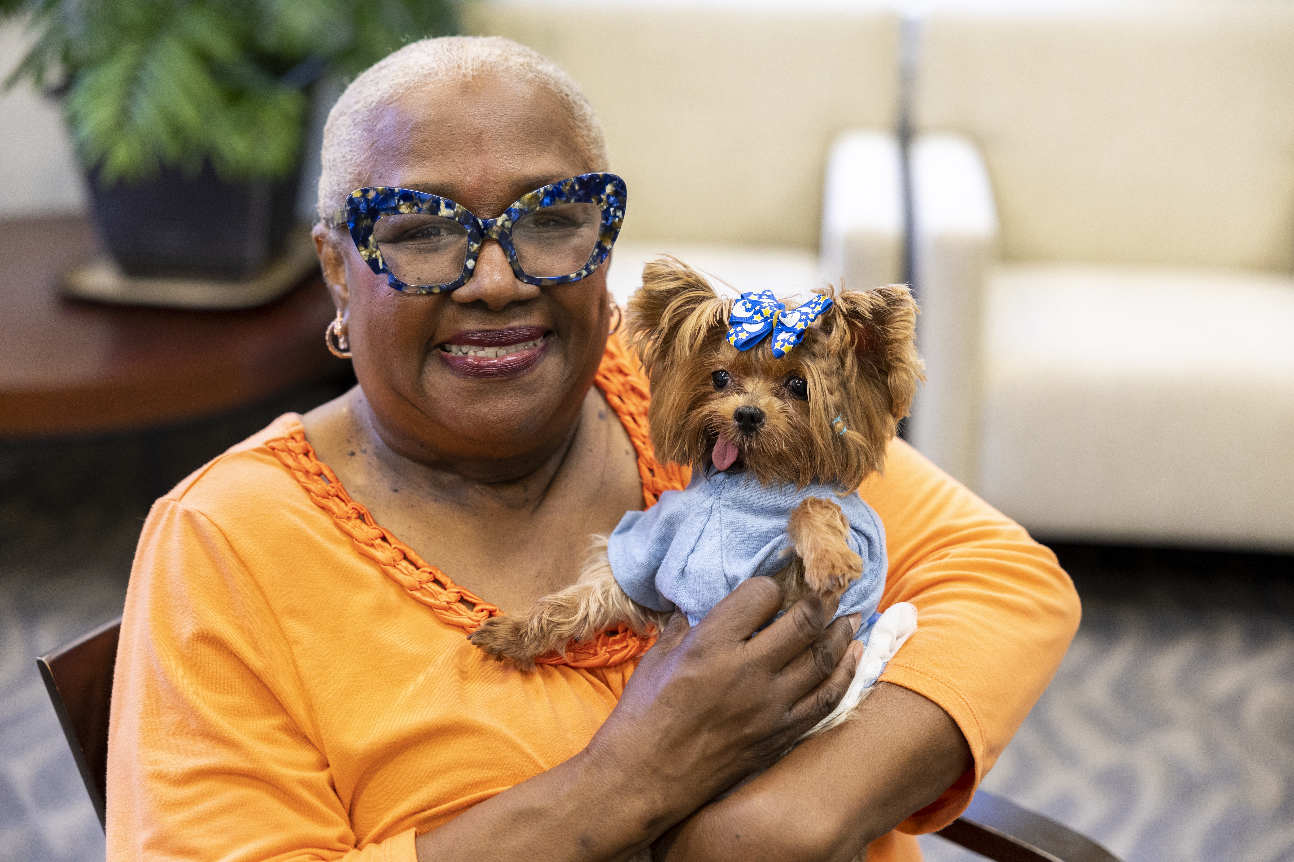
Animal Welfare League
of Alexandria, Senior Services of Alexandria’s AniMeals on Wheels program offers “free”
pet food and delivery to eligible low-income older adults over the age
of 60. Volunteers deliver your request of pet food and other items for your pet(s) on the 2nd Thursday of every month. If you would like to participate, please reach out to Tanya Edwards at, 703-836-4414,
ext. 120.

206 N. Washington Street, Suite 301, Alexandria, VA 22314
703-836-4414 www.seniorservicesalex.org

