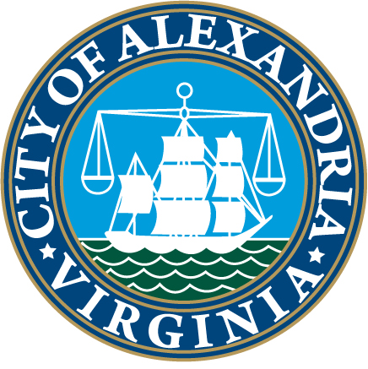
CITY OF ALEXANDRIA, VIRGINIA
SENIOR SERVICES OF ALEXANDRIA
Senior Academy Application
__________________________________________________________________

Eligibility Requirements: To be considered for participation in the Senior Academy, an applicant must be 60 or over and either a City resident or a business owner within the City limits. Class size is limited to 25 participants. Deadline application date is August 22, 2025.

General Information

Name:________________________________________________________________________
(Last) (First) (Middle)

Home Address:_________________________________________________________________

Business Address (If Applicable):__________________________________________________

Primary Telephone: ________________ Work Telephone:______________________

Primary Email Address:_________________________________________________________

Employer:(If Applicable)______________________________________________________

Emergency Contact Information

Name:_____________________________________ Relationship:______________________

Address:___________________________________ Telephone:________________________

Why do you wish to participate in the Senior Academy?
______________________________________________________________________________
______________________________________________________________________________

What do you hope to gain/learn from participation in the Senior Academy?
______________________________________________________________________________
_____________________________________________________________________________

I, the undersigned applicant, certify that the foregoing information is true and complete to the best of my knowledge and belief.

Signature:_________________________________________ Date: ________________________________

If you need special accommodation, please contact Lindsay Hemphill at 703-836-4414, ext. 110 upon acceptance into the class.

Applications may be mailed to Senior Services of Alexandria, 206 N. Washington Street, Suite 301, Alexandria, VA 22314 or emailed to admin@seniorservicesalex.org or communications@seniorservicesalex.org.

