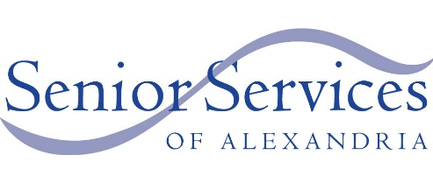
“Senior Living in Alexandria in SPANISH”
SSA’s 2022-2023 Speaker Series
All events are FREE and open to the public.
october |  | Finance Management and Fraud Prevention  Wednesday, October 26, 2022 at 1 pm  Duncan Library, 2501 Commonwealth Avenue
november |  | Paper Flower Making Workshop  Thursday, November 10, 2022 at 1 pm  Duncan Library, 2501 Commonwealth Avenue
More workshops in Spanish are expected to be added soon.
Please check back for details.
For more information, visit www.SeniorServicesAlex.org
or call 703.836.4414, x 123.

