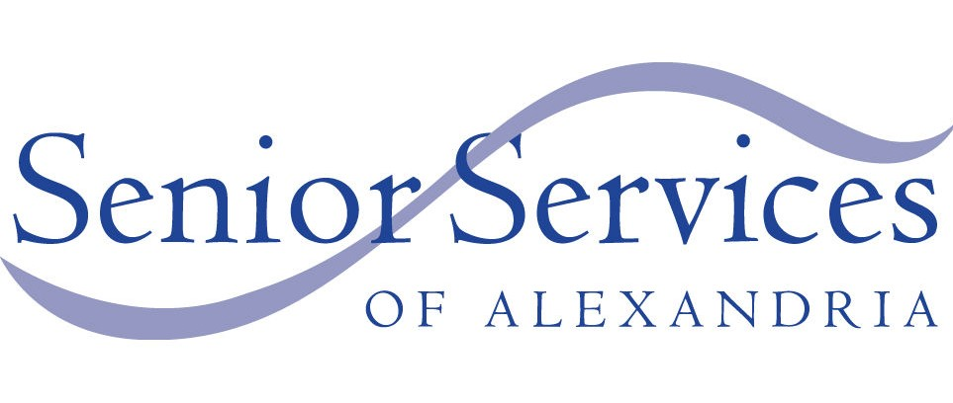
PRESS RELEASE
DRAFT NOT FOR RELEASE
Senior Services of Alexandria Cancels 2020 Gala
Due to the COVID-19 Pandemic Crisis
Continues to Deliver Urgently Needed Services to
Alexandria’s Older Adults
June 16, 2020

Contact: Mary Lee Anderson
Executive Director
executivedirector@seniorservicesalex.org
703-836-4414, ext. 111

Senior Services of Alexandria (SSA) has made the difficult decision to cancel its 2020 Annual Gala due to the continuing COVID-19 pandemic crisis.

“This was a tough decision, said Mary Lee Anderson, SSA’s Executive Director. However, our priority now is to continue to serve the city’s most vulnerable population—our older adults—with programs that are keeping them safe and healthy.”

SSA has been working harder than ever over the past couple of months. We are now delivering nearly 2,500 meals each week (up from 900 weekly in February!) and have over 100 clients in our Groceries to Go program. We are making new “virtual” Friendly Visitor matches and handling DOT reservations daily. We’ve also begun a new weekly e-gram, SSA Connection, with interesting and uplifting information for Alexandria’s older adults, and our Senior Ambassadors get updates to share with their communities three times a week! As Alexandria begins to transition into phased re-opening, SSA staff will continue to manage all this remotely until a gradual return to the office is possible.

“We are very thankful for the generosity of our Gala sponsors and donors for their continued support of SSA during this critical time, said Laurie Blackburn, SSA’s Board Chair. Your donations will allow SSA to continue responding to the increased need for services to the senior population. We are fortunate to live in such a compassionate and caring community.”

###
Senior Services of Alexandria provides services and programs that help foster independence and self-sufficiency, enabling seniors within the City of Alexandria to age with dignity.

